**WEEKLY EVENTS CALENDAR**

Presenting…  
**Circle K International**

**at UC Irvine**

## October 2012

2012 Fall Quarter, Wk 1

Tuesday, October 2, 2012

www.ucicirclek.org

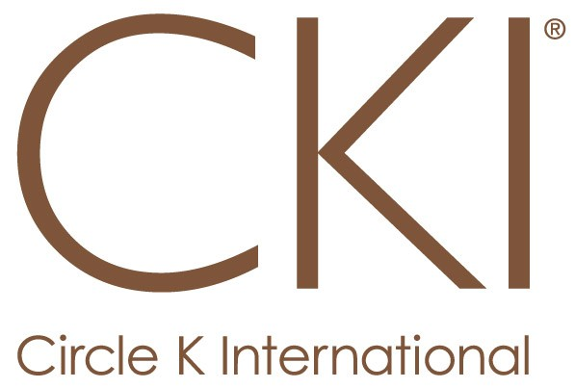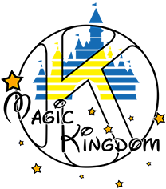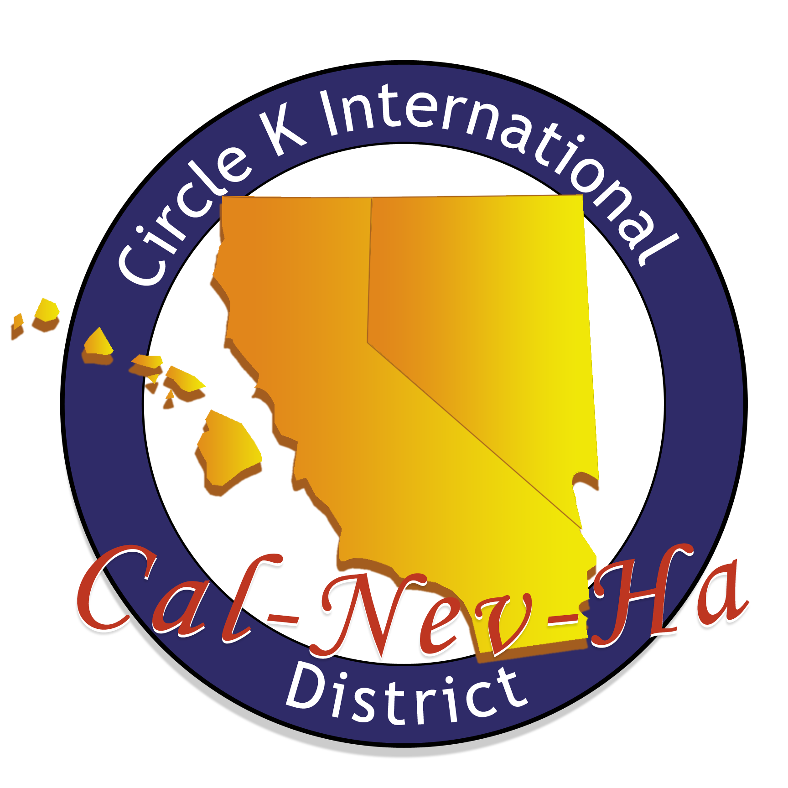

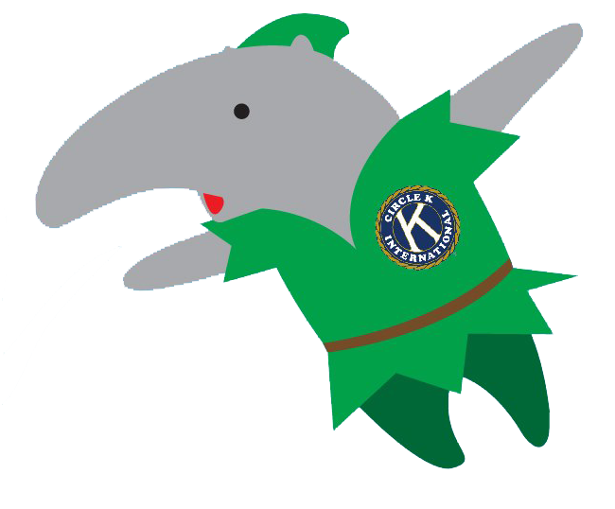



**SERVICE**

**LEADERSHIP**

**FELLOWSHIP**

|  |  |  |  |  |  |  |
| --- | --- | --- | --- | --- | --- | --- |
| SUN | MON. | TUES. | WED. | THURS. | FRI. | SAT. |
| -2nd Sundays @ 8:30am [2nd Sundays of each month]  -Board Meeting @6pm | -Think Together @ 2:50pm  -Coffee Time w/ Sarina @ 3-5pm | -Tabling @ 10am on Ring Road  -General Meeting @ 6pm | -Working Wardrobe @2:50pm | -CDM Kiwanis Meeting @ 11:30am  -Book Doctor @ 3:30pm | -Hemopet @ 8:30am |  |

-**Weekly Events:** Think Together and Book Doctor **CANCELLED; RESUME NEXT WEEK**

-**Read for Record:** Thurs., Oct 4th

* Shift 1: 12-3:30pm [5 people]
* Shift 2: 3:30-6:30pm [6 people]
* Shift 3: 5:30-8:30pm [6 people]

-**Chapman 5K:** Sat., Oct 6th

* Course Monitor: 5:00-10:30am

-**Lake Forest Relay for Life:** Sat., Oct 6th

* Set-Up: 6:30-10:30am

-**Hemopet:** Sun., Oct 7th, 8:30-12pm

-**SIGN UP ONLINE TO ATTEND on our CALENDAR!!!**

-**Want to** **Chair an Event?** 🡪 Contact Amy, VPS

-**Tech. Committee Meeting:**

Thurs., Oct. 4th, @ 6-7pm in CSL Rm. 11

-**CKI 101Workshop:**

Wed., Oct. 10th, @ 7-8pm in SSL 145

-**Fundraising Committee Meeting:**  
Mon., Oct. 8th, @ 5-6pm in SSL 228

-**Single Service Committee Meeting:**

Mon., Oct. 8th, @ 6-7pm in SSL 228

-**DISTRICT-WIDE EVENT:** **FTC**

Nov 2-4; Cost: $70 BY OCT 10TH @ 12pm

-**Write an Article** 🡪 Contact Adrian, Bulletin

-**After Meeting Social: Board Game Night**

@ West Food Court

-**FTC Skit Practice/Prop Committee:**

Wed-Fri., Oct 3-5, @ 8-10pm in HH 3rd floor

**-Ikea Breakfast Social:** Sun., Oct 7th, @ 9am

**-DISTRICT-WIDE EVENT:** **CKI South**

Sat., Oct. 21st; Cost: $6 BY OCT 10TH @ 12pm

-**2012-2013 Member Induction:**

**Tues., Oct. 16th @ Gen Mtg**

**Turn in Member Apps by OCT. 15TH to be a part of THIS FUN EVENT!!!**

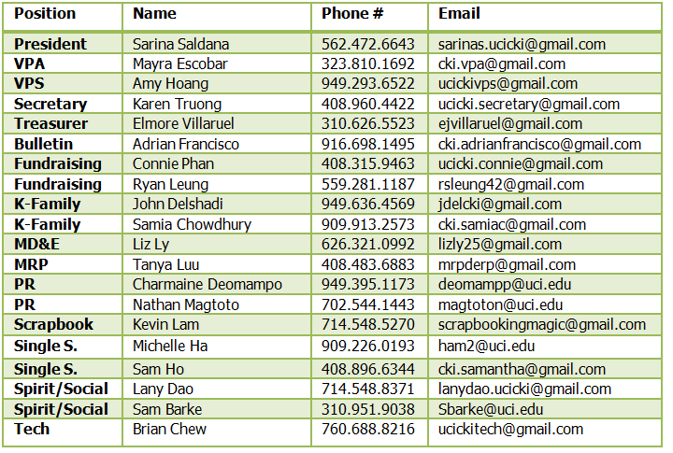

Week 1: Moss Cove A/B

Week 2: Pacific Ballroom D

Week 3 & 4: RH 104

Week 5 & 6: Doheny Beach A  
Week 7: Pacific Ballroom C

Week 8: Pacific Ballroom D

Week 9: RH 104

**Website:** www.ucicirclek.org  
**Facebook:** http://www.facebook.com/groups/242970149059638/  
**Tumblr:** http://ucicki.tumblr.com/  
**Flickr:** http://www.flickr.com/photos/ucicirclek  
**Newsletter:** http://issuu.com/adrianfrancisco

**BOARD CONTACTS**

**GET CONNECTED**

**General Meeting Rooms for 2012 Fall Quarter**

**REMINDERS**

* **Member Application?** Ask a board member or download one from our website: [www.ucicirclek.org](http://www.ucicirclek.org)

- To be a part of **Member Induction**, Apps. are **DUE BY OCT. 15th!!!** Drop off during Gen. Mtg, to any board member, or at Phoenix Grill Tues-Thurs @ 2-3pm to Elmore, Treasurer.

* Click on an event you like on the calendar and **sign up online to attend**: <http://clubs.uci.edu/circlek/SSB_calendar.php>
* **Need a ride?!?!** Meet at the flagpoles for ALL events!
* **Want to chair an event?** Add your name and number on our Chair Doc: <https://docs.google.com/spreadsheet/ccc?key=0AnKaL6lqusFSdFhvbWNYNklING42UEpNSHVCTk9CZ1E&authkey=CICZjZED&authkey=CICZjZED>
* **Want to Submit an Article for “The Second Star?”** Contact our Bulletin Chair, Adrian Francisco! **LATE ARTICLES FOR SEPTEMBER DUE TONIGHT!**